- With the help of a diagram, explain basic building blocks of Convolutional Neural Network (CNN) architecture

A Convolutional Neural Network (CNN) is a deep learning model mainly used for image and video processing. It automatically learns spatial features from input data.
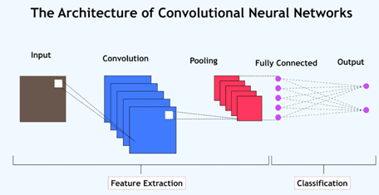

Basic CNN Architecture (Diagram)
Input Image
↓
Convolution Layer
↓
Activation Function (ReLU)
↓
Pooling Layer
↓
Convolution + ReLU + Pooling (repeated)
↓
Flatten Layer
↓
Fully Connected Layer
↓
Output Layer

Building Blocks of CNN
1. Input Layer
- Accepts raw input data (e.g., image pixels).
- Image represented as height × width × channels.
Example:
28 × 28 × 1 (grayscale image)

2. Convolution Layer
- Applies filters (kernels) to the input image.
- Extracts features like edges, textures, and shapes.
- Produces feature maps.

Key parameters:
- Filter size
- Stride
- Padding
3. Activation Function (ReLU)
- Introduces non-linearity.
- Commonly used: ReLU (Rectified Linear Unit)
f(x)=max⁡(0,x)f(x) = \max(0, x)f(x)=max(0,x)
- Helps CNN learn complex patterns.

4. Pooling Layer
- Reduces spatial dimensions of feature maps.
- Decreases computation and overfitting.
- Most common: Max Pooling
Example:
2 × 2 max pooling selects the maximum value.

5. Flatten Layer
- Converts 2D feature maps into a 1D vector.
- Prepares data for fully connected layers.

6. Fully Connected (Dense) Layer
- Neurons are fully connected to previous layer.
- Performs high-level reasoning and classification.

7. Output Layer
- Produces final prediction.
- Activation depends on task:
  - Softmax → multi-class classification
  - Sigmoid → binary classification
  - Linear → regression

- Explain the working principles of Deep Forward (Feedforward) Networks with architecture

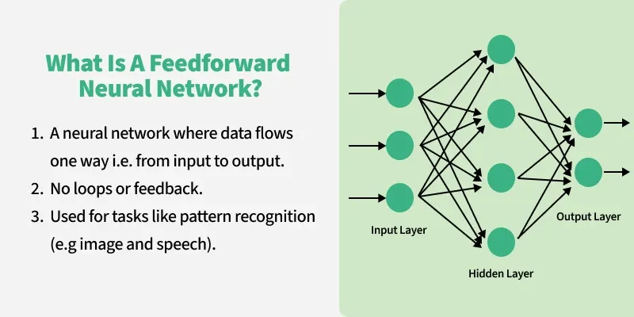
Definition: A Deep Forward Network, also called a Deep Feedforward Neural Network (DFNN), is an artificial neural network in which information flows only in one direction, from the input layer to the output layer, through one or more hidden layers. There are no cycles or feedback connections.

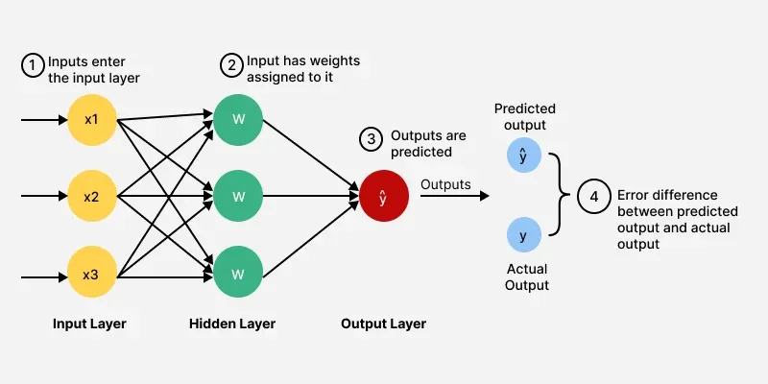

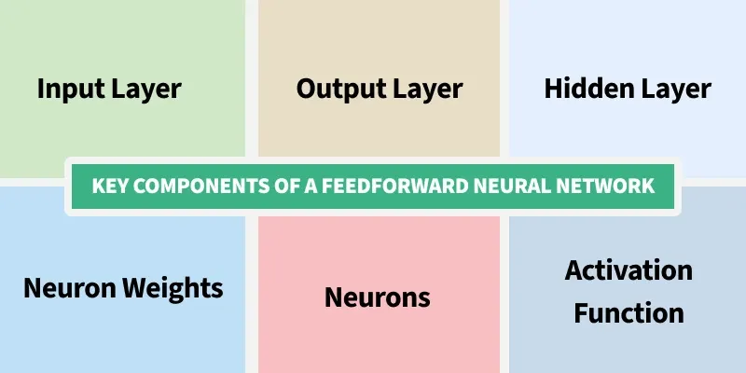

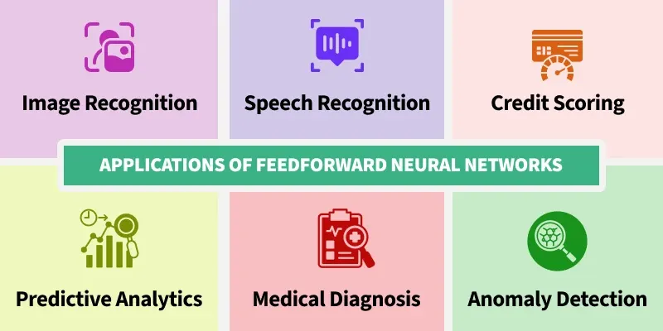

Architecture of a Deep Feedforward Network
Input Layer Hidden Layer 1 Hidden Layer 2 Output Layer
(x1, x2, … xn) → (h1, h2) → (h3, h4) → (y)
Or in layered form:
Input → Hidden Layer(s) → Output

Components:
- Input layer – receives input features
- Hidden layers – perform feature transformation
- Output layer – produces final prediction

Working Principles

1. Input Layer
- Takes input features x1,x2,...,xnx_1, x_2, ..., x_nx1​,x2​,...,xn​.
- Passes values to the first hidden layer.

2. Weighted Sum and Bias
Each neuron computes:
z=∑wixi+bz = \sum w_i x_i + bz=∑wi​xi​+b
where
wiw_iwi​ = weights,
bbb = bias.

3. Activation Function
- Applied to introduce non-linearity.
- Common activation functions:
  - ReLU
  - Sigmoid
  - Tanh
a=f(z)a = f(z)a=f(z)

4. Hidden Layers
- Multiple hidden layers allow the network to learn complex and hierarchical features.
- Each layer processes the output of the previous layer.

5. Output Layer
- Produces the final result.
- Activation depends on the task:
  - Sigmoid → binary classification
  - Softmax → multi-class classification
  - Linear → regression

6. Training Process
- Forward Propagation
  - Input passes layer by layer to produce output.
- Loss Calculation
  - Difference between predicted and actual output is computed.
- Backpropagation
  - Error is propagated backward.
  - Gradients are calculated using chain rule.
- Weight Update
  - Weights are updated using gradient descent.

Characteristics of Deep Feedforward Networks
- No feedback connections
- Supports deep learning
- Learns complex patterns
- Requires large data and computation

Applications
- Image classification
- Speech recognition
- Medical diagnosis
- Credit scoring

- Write and explain Gradient descent and the back-propagation algorithm.

Gradient Descent Algorithm: Gradient Descent is an optimization algorithm used to minimize the loss (cost) function of a machine learning or neural network model by iteratively updating the model parameters (weights) in the direction of the negative gradient.

Working of Gradient Descent
- Initialize weights with small random values.
- Compute the loss function J(θ)J(\theta)J(θ).
- Calculate gradients (partial derivatives of the loss with respect to each parameter).
- Update weights using the update rule:
θ=θ−α∂J(θ)∂θ\theta = \theta - \alpha \frac{\partial J(\theta)}{\partial \theta}θ=θ−α∂θ∂J(θ)​
where
α\alphaα = learning rate.
- Repeat the process until convergence (minimum loss).

Types of Gradient Descent
- Batch Gradient Descent – uses entire dataset.
- Stochastic Gradient Descent (SGD) – uses one sample at a time.
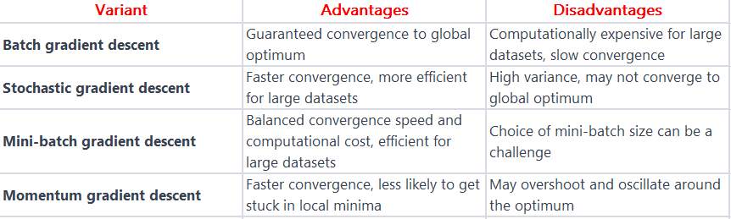
- Mini-Batch Gradient Descent – uses small batches.

Advantages
- Simple and efficient
- Works well with large datasets
- Widely used in deep learning

Back-Propagation Algorithm: Back-Propagation is a supervised learning algorithm used to train multi-layer neural networks. It minimizes the error by propagating the error backward through the network and updating weights using gradient descent.
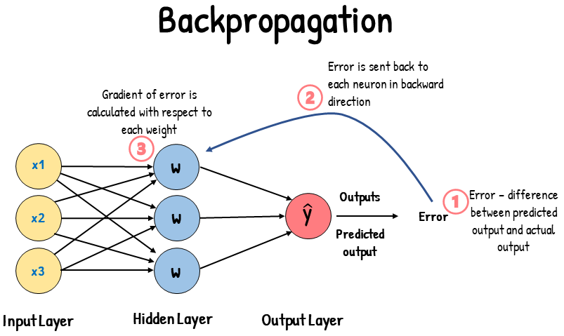

Working of Back-Propagation

1. Forward Pass
- Input data is passed through the network.
- Outputs are computed layer by layer.
- Loss is calculated using a loss function.

2. Error Computation
- Error is calculated as the difference between actual output and predicted output.

3. Backward Pass
- Error is propagated backward from output layer to input layer.
- Gradients are computed using the chain rule.

4. Weight Update
- Weights are updated using gradient descent:
w=w−η∂E∂ww = w - \eta \frac{\partial E}{\partial w}w=w−η∂w∂E​
where
η\etaη = learning rate,
EEE = error.

5. Iteration
- Steps are repeated for multiple epochs until error is minimized.

Advantages
- Enables training of deep networks
- Efficient error minimization
- Supports complex non-linear models

Relationship between Gradient Descent and Back-Propagation
- Back-Propagation computes gradients efficiently.
- Gradient Descent uses these gradients to update weights.
- Together, they form the core of neural network training.
